**Input:**

2x1 + x2 + x3 = 5

2x1 + x2 + x3 = -2

-2x1 + 7x2 + 2x3 = 9

**Output:**

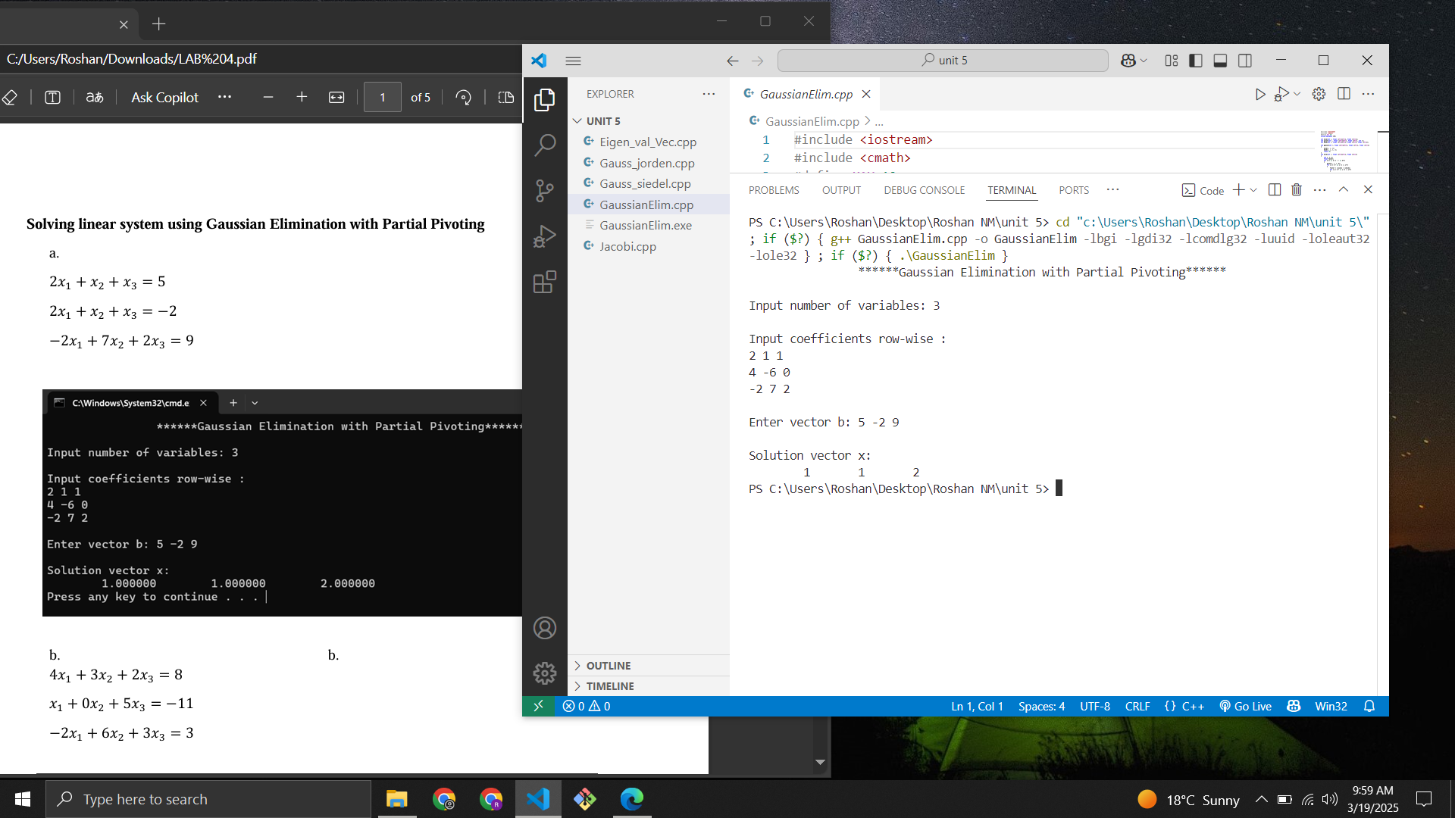

**Input:**

4x1 + 3x2 + 2x3 = 8

X1 + 0x2 + 5x3 = -11

-2x1 + 6x2 + 3x3 = 3

**Output:**

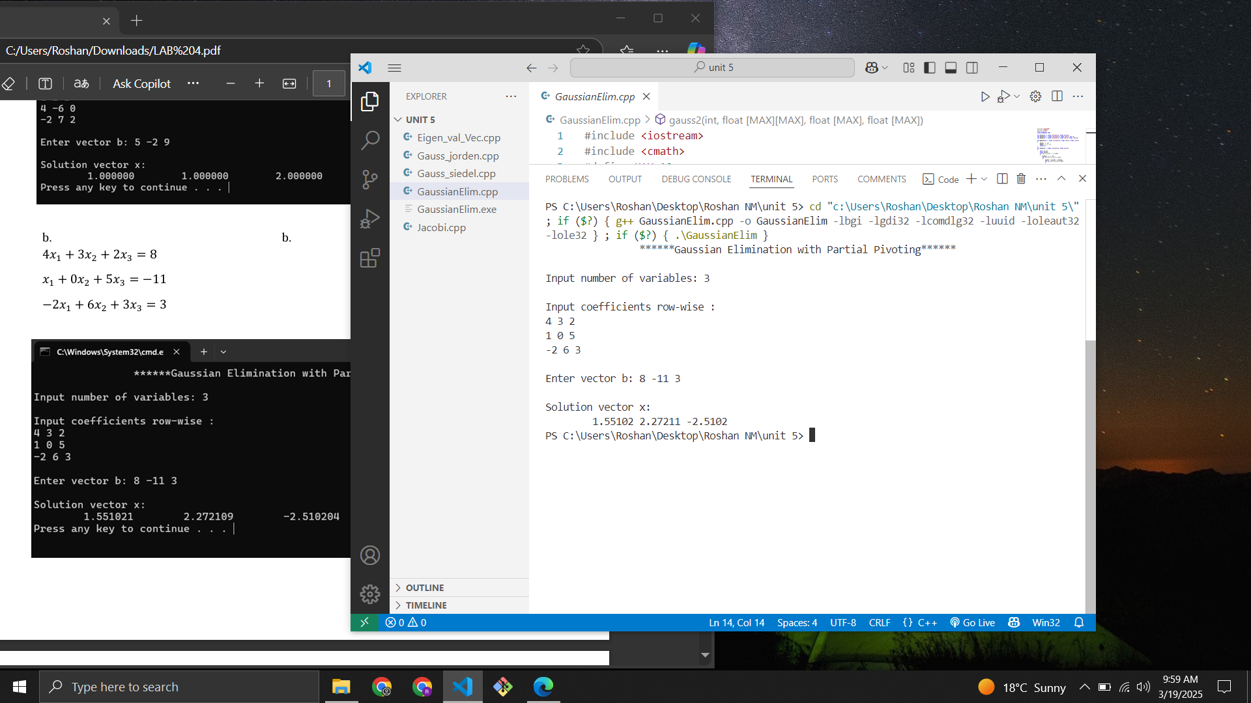

Input:

4x1 – 2x2 + x3 = 15

-3x1 – x2 + 4x3 = 8

x1 – x2 + 3x3 = 13

Output:

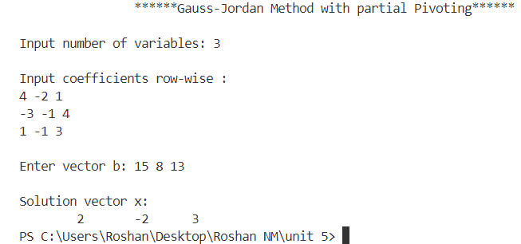

Input:

3x1 + 5x2 – 5x3 = 12

4x1 – 5x2 + 3x3 = 4

x 1 + 0x2 + 4x3 = 3

Output:

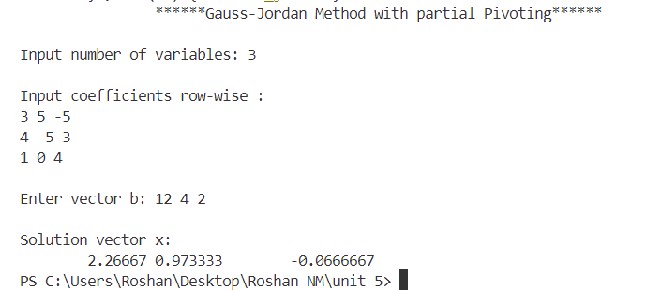

Input:

4x1 + x2 + 2x3 = 4

3x1 + 5x2 + x3 = 7

x1 + x2 + 3x3 = 3

Output:

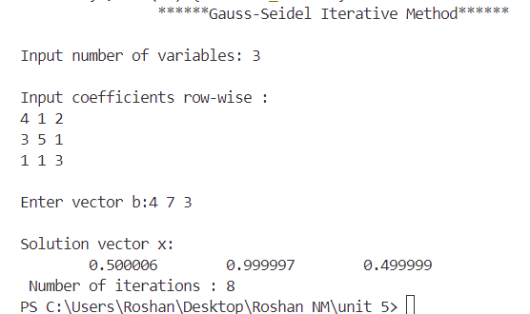

**Input:**

10x1 + x2 + x3 = 12

2x1 + 10x2 + x3 = 13

2x1 + 2x2 + 10x3 = 14

**Output:**

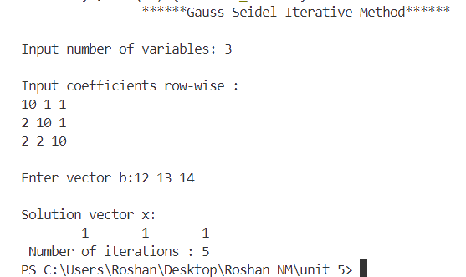

**Input:**

4𝑥1 +𝑥2 +2𝑥3 = 4

3𝑥1 +5𝑥2 +𝑥3 = 7

x1 +𝑥2 +3𝑥3 = 3

**Output:**

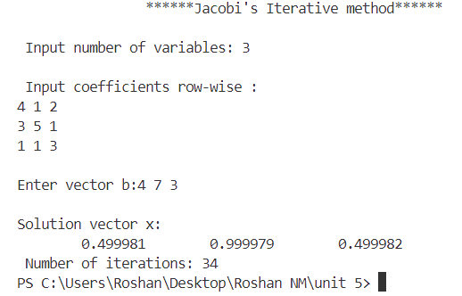

**Input:**

10𝑥1 +𝑥2 +𝑥3 = 12

2𝑥1 +10𝑥2 +𝑥3 = 13

2𝑥1 +2𝑥2 +10𝑥3 = 14

**Output:**

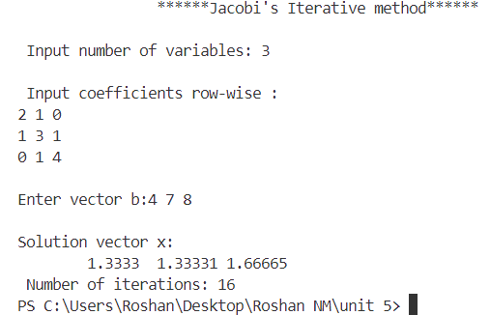\

**Input:**

3 -1 0

-3 4 3

0 -1 1

**Output:**

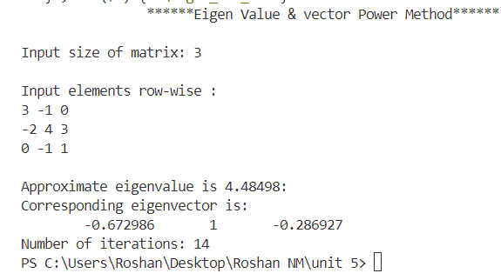

**Input:**

2 1 0

1 3 1

0 1 4

**Output:**

